Extensions

The next 15-20 pages have a TON of labs, activities, websites, and ideas to inspire you as you think about what to do next, whether you’re at camp, or at home after camp is over.

- Microscope lab examining plant and animal cells
- Exploring phylogenetic trees: a set of web-based activities to learn how to categorize organisms, according to their relatedness.
- Tree of life: a series of web-based readings and activities to explore the evolving way that scientists are thinking about the ways that they categorize organisms.
- The Fossil Record: web-based readings and activities to explore how fossils are made, how scientists determine the age of fossils and other related work.
- Darwin’s Journey: so much of what we now understand about the role of evolution, natural selection, and diversity are the result of what Darwin discovered and shared with the world. Here a collection of web-based readings and activities to take you through his travels, journals, what we currently know, etc.
- Intro to DNA
- Build a model of DNA: This is an activity that will take you through the steps of constructing a model of DNA using candy and/or art supplies.
- Genetics, inheritance, and probability reading. This reading will give you more information about these foundational topics, and will take you step-by-step through the process of completing a simple Punnett Square.
- All in the Family: an activity to determine the /traits of a set of parents, the probability of how their offspring will inherit these traits, and the creation of this Paper Pet Family.
- Making Pedigrees: learning how to make a family pedigree and track the appearance of specific traits in a family tree.
- 23andMe extensions: a series of web-based 23andMe extensions to investigate more details about muscle composition, scientific explanations, etc.
- Literary extensions: a series of ideas to translate what you’re learning into a variety of written formats (poems, articles, lessons, children’s books, letters, etc.

Microscope extensions:

Bring something from home that’s realllllly small that you’d like to look at under a microscope, and create a piece of art using what you see on multiple magnifications.

Onion/Cheek Cell Lab – The Lab

Part One: The Onion

Materials:
- Microscope  - Slide  - Cover Slip  - Toothpick (round)  - Dropper | - Tweezers  - 5% sodium chloride solution  - Freshly cut onion chunk  - Lugol solution (iodine)

Procedure:

- Cut an onion in half. It doesn’t have to be a red onion. Any onion will do!  - Using tweezers or your fingers, carefully peel a thin layer of the onion from the inside surface of one of the rings of the freshly cut onion chunk. | 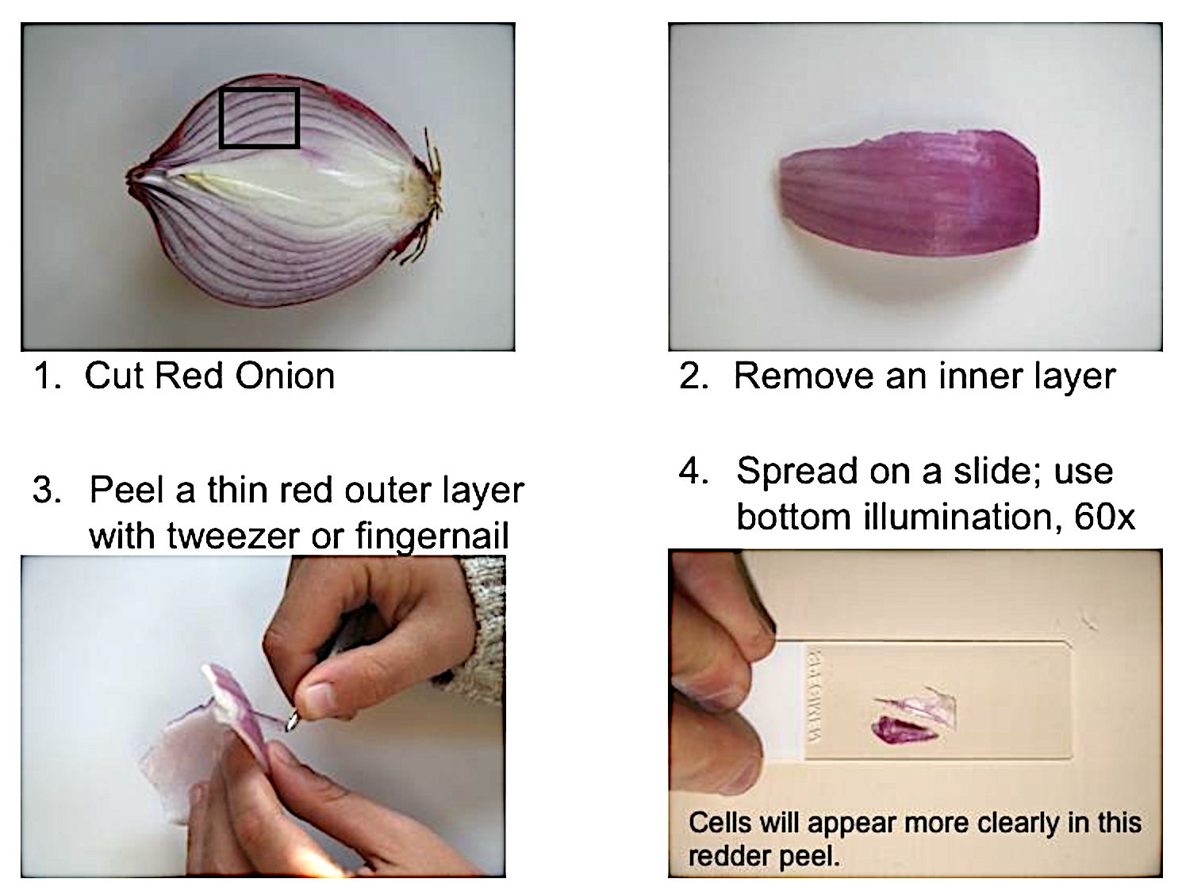
 | Make a temporary wet-mount slide from this layer of onion. Use a toothpick to spread out the onion on the slide. Make sure that the onion is not folded or it will be too thick to see through with your microscope.
- Place the slide on the stage of your microscope and examine it using the low power first. Look for a group of cells.

    - Are all of the cells basically the same shape?
    - Describe the shape or shapes of the cells that you see

Some objects are too transparent to see under the microscope. You can stain them to give them color. After they are stained you will be able to see them with your microscope. There are many kinds of stains. Lugol solution is a stain containing iodine. You will use Lugol solution to help you to see some additional parts of the cells.

- Carefully remove the slide from the stage of your microscope.
- Remove the cover slip and gently place a drop of Lugol’s solution on the onion layer.
- Carefully place the cover slip back on the onion and return the slide to the stage of your microscope.
- Examine the slide using low, medium and high power.

- Describe the parts of the cell that you can see now that were not visible to you in the unstained slide
- Why did you use Lugol’s solution?
- Draw what you see in these these circles for both low and high power. Label what you see (you might have to do some research to do this!).

Specimen Name  Magnification | Specimen Name  Magnification

- Did you see chloroplasts*? Why/Why Not?

*You’re probably gonna need to figure out what a chloroplast is, which you should definitely do because it’s important… and interesting.

Part Two: Cheek Cells

Materials:
- Microscope  - Slide  - Cover Slip  - Toothpick (flat) | - 50 ml beaker  - Alcohol  - Dropper  - Lugol solution

Procedure:

- Place about 20 ml of alcohol in a clean 50 ml beaker. Tilt the beaker and place the flat end of the toothpick into the alcohol in the beaker to sterilize the toothpick. Leave the toothpick in the alcohol for a minute or two.
- Gently rub the flat end of the sterilized toothpick on the inside of your cheek, inside your mouth.
- Spread the material from the toothpick onto the center section of a clean slide. Try to spread out the material to an area slightly smaller than the size of a cover slip.
- Place a drop of Lugol’s solution on the center of the slide and put a cover slip over the solution.

- Why was the toothpick sterilized before scraping the inside of your cheek?

- Examine the slide under low power. Look for a few cells that are not piled up on top of each other.

- Are all of the cells basically the same shape?
- Describe the shape or shapes of the cells that you see
- In what way(s) are these cells the same as the onion cells?
- How are these cells different from onion cells?

Draw and label what you see on low power.

Specimen Name  Magnification | Specimen Name  Magnification

- Examine the cells using high power. Draw and label what you see on high power.
Specimen Name  Magnification | Specimen Name  Magnification

Anthropology 201 – Extension Ideas

Human Evolution

http://www.pbs.org/wgbh/nova/evolution/dawn-of-humanity.html

http://www.hhmi.org/biointeractive/biology-skin-color

http://www.pbs.org/wgbh/nova/search/results/page/1/include-teachers/only?facet%5B0%5D=dc.subject_teacher%3A%22Anthropology%22&facet[]=dc.subject%3A%22Evolution%22

http://video.nationalgeographic.com/search?q=evolution

What did it take to survive for early hominids? Cooperation (no, really!)! And…

http://humanorigins.si.edu/human-characteristics/social-life

http://www.livescience.com/46662-early-humans-evolving-traits-revealed.html

Exploring Phylogenetic Trees
http://www.hhmi.org/biointeractive/classroom-activities-biodiversity-and-evolutionary-trees

Read more about the Tree of Life

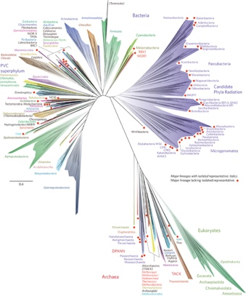 | http://www.nature.com/articles/nmicrobiol201648  http://www.kidzsearch.com/wiki/Tree_of_life_(biology)  http://kids.britannica.com/comptons/art-158395/The-tree-of-life-according-to-the-three-domain-system  https://student.societyforscience.org/article/assembling-tree-life

Using DNA to create phylogenetic trees
http://www.hhmi.org/biointeractive/creating-phylogenetic-trees-dna-sequences

Fossil Record:
http://nature.nps.gov/geology/nationalfossilday/activities.cfm (lots of ideas/things to try)
http://www.ucmp.berkeley.edu/education/explotime.html

Darwin’s Journey:
http://www.aboutdarwin.com/index.html
http://www.amnh.org/exhibitions/darwin/a-trip-around-the-world/
http://www.amnh.org/our-research/darwin-manuscripts-project/journal-pocket-diary/1838-1881 (shortcut to Darwin’s handwritten journals)

Intro to DNA

Goal: Beginning understanding of the structure (shape) and components (pieces) of DNA.

DNA is made up of four nucleic acids: Adenine, Thymine, Cytosine and Guanine. Without exception (in DNA) Adenine shares two bonds with Thymine, and Cytosine shares three bonds with Guanine.

A piece of DNA might look like this  Question: do you think DNA actually looks like this? | T=A  A=T  T=A  C≡G  A=T  A=T  G≡C  C≡G
Both sides of the DNA have a “backbone” made up of sugar and phosphate that hold it all together.

So, with the sugar and the phosphate, a piece of DNA might look like this  But it doesn’t look like that really! This is a model to help you make sense of the pieces. | 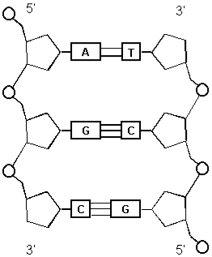

Making a Model of DNA

Goal: A deeper understanding of the structure and components of DNA, and its ability to twist.

The “building blocks” of DNA are:
- sugar  - phosphate | - adenine  - thymine  - cytosine  - guanine

Materials:
- Twizzlers  - Gummy Bears (different colors)  - Toothpicks | and/or | - Pipe cleaners (different colors)  - Pony beads (different colors)

Brainstorm:

Before you read the instructions, think about this:
- What do you already know about the structure of DNA?
- What do you need to represent in your model?
- What materials do you have?
- How can you use what you have to build a model of DNA?

DNA is made up of… (hint: write down what it’s made up of):
What you write here…

will end up here

I will use to represent and
to represent and
to represent and
to represent and
to represent and
to represent .

Directions:

Candy:  Use the twizzlers to represent the backbone of the DNA. This backbone is made up of phosphate and sugar.  Pick four different colors of gummy bears, one for each of the four bases (adenine, thymine, cytosine, and guanine). Remember that you need to have equal amounts of adenine and thymine, and equal amounts of cytosine and guanine. Do you remember why?  Make a key:  Adenine  Thymine  Cytosine  Guanine  Use a toothpick to represent the bond that holds the base pairs together. Don’t worry, the gummy bears can’t feel anything. Don’t forget that adenine and thymine are always together (see what I did there?), and cytosine and guanine are a close group. Make sure the gummy bears are head-to-head on the toothpick and that. That will make sure that there is enough toothpick left to attach the gummy bears to the twizzlers, like this:  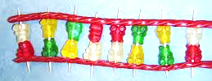  When you put together all of the pieces, hold one end in your left hand, and the other end in your right hand, and twist. This will give you an idea of how DNA coils up. | Art supplies:  Pick one color of pipe cleaner to represent the backbone (sugar and phosphate part of DNA).  Pick another color to represent the crossway bonds. Cut this pipe cleaner into smaller two inch pieces.  Pick four different colors of pony beads, one for each of the four nitrogen bases (adenine, thymine, cytosine, and guanine). Reminder: you need the same number of adenine and thymine, and cytosine and guanine. Do you remember why?  Make a key:  Adenine  Thymine  Cytosine  Guanine  Add two beads to each two-inch piece of pipe cleaner. Make sure that adenine and thymine are always together (see what I did there?), and cytosine and guanine are a close group.  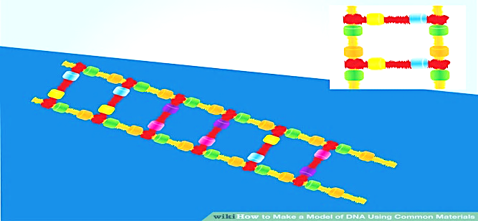  Attach the two-inch pieces of pipe cleaner with the two pony beads to the backbone pipe cleaners.  When you put together all of the pieces, hold one end in your left hand, and the other end in your right hand, and twist. This will give you an idea of how DNA coils up.
Key Ideas

Genes control the traits passed from generation to generation. It is possible to predict the likelihood of inheritance of certain traits. Even if it’s a 100% prediction, it’s still not a sure thing!

Heredity of Traits. The sex cells that combine at fertilization, join to form a single cell through sexual reproduction. The new cell contains chromosomes from each parent. The chromosomes are made up of a series of genes (which are made up of alleles, half from each parent). Genes determine which traits, or characteristics, the new organism will inherit from its parents. The passing of traits from parents to offspring is known as heredity.

Some traits are controlled by two genes, or a gene pair. One gene is inherited from each parent. If one gene in the pair is dominant, that gene will get expressed. The organism will show the trait of the dominant gene (remember: phenotype?!!). We only see recessive traits when the recessive alleles from both parents are recessive. If the dominant gene is present, that is what we see.

A homozygous organism has two genes that are alike (homo is a prefix meaning “same”) for a particular trait. They can either be two dominant or two recessive genes. A heterozygous organism has two genes that are different (hetero, meaning “different”) for a trait, one dominant and one recessive.

Predicting Traits. You can predict the traits an organism might inherit if you know what gene pairs the parent has. A Punnett Square is a diagram that helps you make such predictions. Let’s take a closer look at the trait for hair texture in humans.

The gene for curly hair in humans is dominant. The gene for straight hair is recessive. A capital letter is often used to represent the dominant gene; a lower case letter is used to represent the recessive gene. In this case, C stands for curly hair, c stands for straight hair.

In our example, the mother is homozygous recessive for hair texture. Her genes are represented as cc.

Step 1  We write the first gene, c, of the mother’s gene pair above the top left-hand square. The second c is written above the top right-hand square. In this example, the father is heterozygous for this trait. His genes are represented as Cc. We show this by writing C to the side of the upper left-hand square and c to the side of the lower left-hand square. See Figure | Mom Dad c c  C  c
Next we find the different combinations of genes that can be inherited be the child.
Step 2  In each square, we write the gene from the side of the square next to the gene from above the square. See Figure To the side of the top left-hand square is the first gene from the father’s gene pair, C. Above the square is the first gene of the mother’s gene pair, c. So we write Cc in the top left-hand box | c c  C Cc  c
Step 3  In the top right-hand box, we write the first gene from the father’s pair and the second gene from the mother’s pair. We write Cc in that square.  See Figure | c c  C Cc Cc  c
Step 4  To fill in the bottom left-hand box, we match the second gene of the pair from the square’s side, c, with the first gene of the pair above, c.  See Figure  There’s one more step… | c c  C Cc Cc  c cc
Step 5  To complete the square, we pair the second gene of the pair to the square’s side, c, with the second gene from the pair above the square, c.  See Figure | c c  C Cc Cc  c cc cc

By using a Punnett Square, you find that two gene combinations are possible from these two parents. The offspring will either be heterozygous (Cc) or homozygous recessive (cc) for the trait of hair texture. The heterozygous person will have curly hair, the homozygous person, straight.

There are many traits that are controlled by more than one gene pair.

Genetics - All in the Family: Paper Pet Project (Digging into inheritance and probability)

If you want to do this, you will need to complete the Key Ideas reading first (unless you already know about Punnett Squares!)

Have you ever been surprised to see two people who looked alike but were not related? On the other hand, you’ve probably been surprised when family members do not share the same physical characteristics. You may have wondered what causes people to look the way they do, or why their offspring commonly look like their parents. These are the questions that geneticists are trying to answer as they study the inheritance of traits.

In this project you will explore how traits are passed from parent to offspring, from generation to generation, by creating a family of paper pets.

First you will create your own paper pet parents by choosing its characteristics.

Then you will cross their alleles using Punnett squares to identify the genotypes and phenotypes for each of four offspring (one offspring for each of the four squares in the Punnett square).

As a final step, exchange genotype data for one of your offspring with a classmate and complete a second generation (of four additional individuals) with those two pets.

When you are finished you should have two parents that become grandparents, and four offspring, for a total of six paper pets.

Project Guidelines:

Use the worksheet to help you create your paper pets. Cut out your first generation pet from the green paper (they are larger). Choose the traits for your pet: gender, eye shape, nose shape and teeth shape. Use any material you would like to decorate your pets.

On the back of your pet, write the alleles it has for each trait (this is its genotype). Use XX for female and XY for male. For the other traits, the dominant alleles are for square eyes, triangular nose and pointed teeth; recessive traits are for square eyes, oval nose and square teeth (they are also indicated on the chart below).

Using Punnett squares, cross the alleles of both parents for each of the traits (gender, eye shape, nose shape and teeth shape). You will have four Punnett Squares to hand in with your project. Use the information in each of the quadrants of the Punnett squares to create the next generation of paper pets. Be consistent: use the upper left-hand corner for one pet, the upper right-hand corner for the second, the lower left-hand for the third and the lower right-hand for the fourth. On the back of the pets write the alleles it has for each trait and decorate however you wish.

Swap one of your second generation pets with that of one of your classmates. Pick another of your second generation pets and cross it with the one you received from your classmate. Again, you will have four Punnett Squares to hand in with your project. Use the information in each of the quadrants of the Punnett squares to create the third (and final) generation of your paper pets. Be consistent: use the upper left-hand corner for one pet, the upper right-hand corner for the second, the lower left-hand for the third and the lower right-hand for the fourth. On the back of the pets write the alleles it has for each trait and decorate however you wish.

Make a display of your pet family, making sure to label the different generations (P, F₁, F₂). You will present your paper pets to the class, sharing with us one thing that you found surprising and/or interesting.

Hints

- Remember: if your original pet has a trait controlled by a dominant allele, you can choose whether the genotype is homozygous dominant or heterozygous for the trait.

- Remember that each of the offspring must inherit their traits from the parents, following the laws of genetics (for now, no mutations).

- Set up your display so that it is easy to turn over the pets and read their genotypes.

Possible Traits | Dominant  (except for sex) | Recessive  (except for sex)
Sex | Female | Male
Eyes | Square | Round
Nose | Triangular | Oval
Teeth | Square | Pointed

Materials
- Construction paper  - Scissors  - Glue | - Markers  - Materials to decorate

Procedure
- For your first generation, cut out the pets following the printed outline. Start with the largest of the pets (this is your P generation) printed on green paper.

- On the front of your paper pet, draw the phenotypic traits you have chosen for it. Use the table to determine how the traits should be indicated.

- On the back of your pet, write the alleles it has for each trait (this is its genotype). Use XX for female and XY for male. For the other traits, the dominant alleles are for square eyes, triangular nose and pointed teeth; recessive traits are for square eyes, oval nose and square teeth Give your pet a name and write it at the top of the chart and decorate your pet as you wish (be creative and have some fun!).

- Using Punnett squares, cross the alleles of both parents for each of the traits (gender, eye shape, nose shape and teeth shape). You will have four Punnett Squares to hand for this part of your project. Use the information in each of the quadrants of the Punnett squares to create the next generation of paper pets. Be consistent: use the upper left-hand corner for one pet, the upper right-hand corner for the second, the lower left-hand for the third and the lower right-hand for the fourth.

- Cut out the pets for the second generation following the printed outline on the yellow paper (this is your F₁ generation). This is the medium-sized paper pet. On the back of the pets write the alleles it has for each trait and decorate your pet however you wish just as you did for the first generation.

- Make a display of your pet family, making sure to label the different generations (P, F₁, F₂). You will present your paper pets to the class, sharing with us one thing that you found surprising and/or interesting.

Making Pedigrees

A pedigree is a diagram that shows how traits are passed from generation to generation. A pedigree usually starts with a married couple in the first generation (P), and then shows their children in the second generation (F₁), their grandchildren in the third generation (F₂), and so on.

Standard symbols are used to represent males (square) and females (circle), and the relationships among them (see below).

Track a trait through your family tree!

Things to think about:
- What do you notice about who shares (or doesn’t share) a trait?
- Does the trait skip a generation?
- Is the trait only visible in male/female family members?
- What about personality traits? Do those appear even among relatives who don’t share genes?

Check these sites out:
http://www.gmsdk12.org/Downloads/Pedigree%20Chart%20Worksheet.pdf
http://www.progenygenetics.com/online-pedigree/ (online program to make one!)
Go online a search for “Build a Pedigree Activity – Unit 6” It’s a great intro

23andMe extensions (scientific background, explanations)

Want to learn more about your muscle composition?
https://you.23andme.com/reports/wellness.muscle_composition/ (you will have to log in)
- Genetically, I should be a sprinter (I am not!). What does your report say about you?
- How does the gene affect muscle composition?
- How does training change things?
- Is this super impactful?
- Check out the “Scientific Explanation” page
- Is the variant a result of a mutation?

Literary Thoughts:

Read about the discovery/identification of a trait, read a person’s story about their experience with that trait (positive/challenging), then write about your experience with that trait.

Write a Haiku about each of the camp moments/activities that were particularly meaningful to you.

Write a book for your classmates or young children about something you would want to share with other kids.

Write a newspaper article about camp.

Write a letter to a scientist you’d like to meet and have a conversation with over lunch/dinner.

Write a letter to a government official with information and suggestions to improve people’s lives using and learning about science.

